**Software Engineering Department**

**Course Name: CMPE281– Cloud Technologies**

Student Name: Vibhava Rayala

Instructor: Jerry Gao, Ph.D., Professor

Playing with the developer’s console on salesforce, Building an app on salesforce, Creating events, fields & records on it. Enabling API for the app.

**Summary:**

This document contains step by step demonstration of Salesforce Developers Console Registration, configuration, development environment, Building an app on the developers website in salesforce, Creating events, fields and records and enabling API’s for the app.

**Objectives:**

1. Salesforce Developers Website registration.
2. Building an App on the developers website of salesforce
3. Creating Events on the app
4. Creating custom field validations on the app.
5. Enabling API for the app.

**Requirements:**

1. Must have an account on Salesforce Developers Website.

**How to do it? :**

1. Creating an account on <https://developer.salesforce.com/> . My email address is [vibhava.rayala@gmail.com](mailto:vibhava.rayala@gmail.com), I registered with this address.

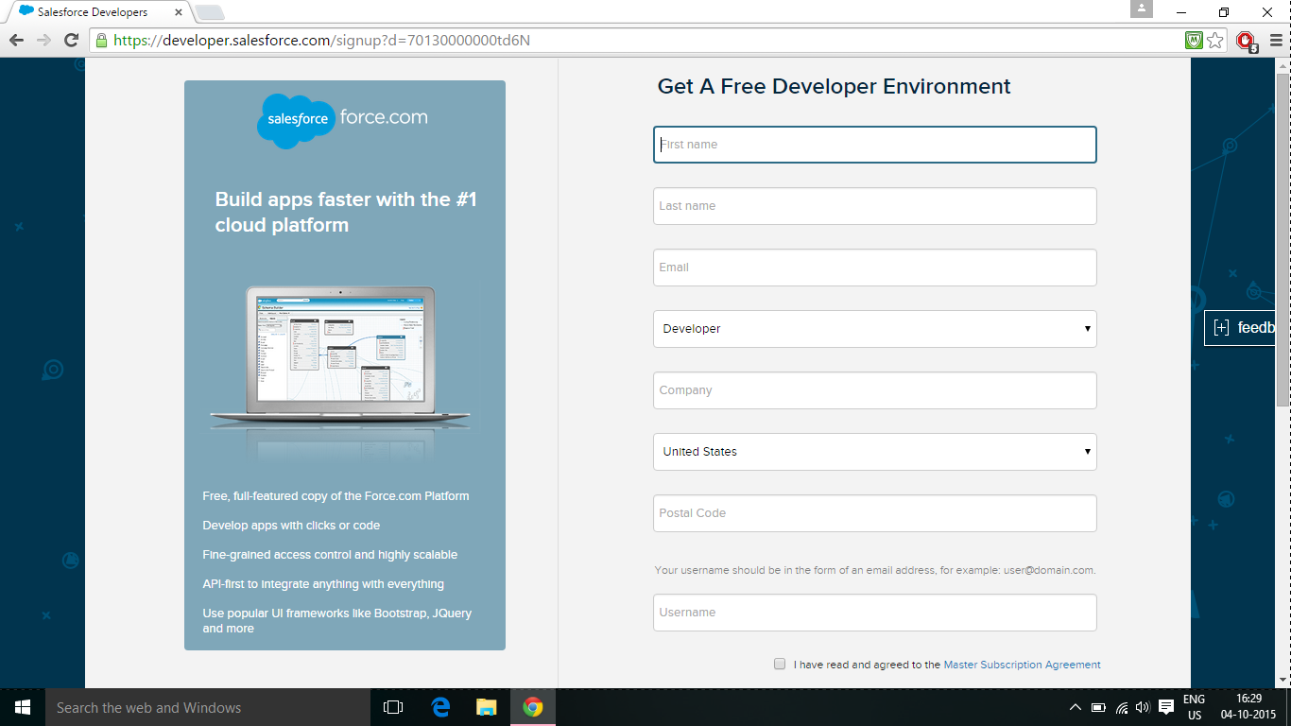

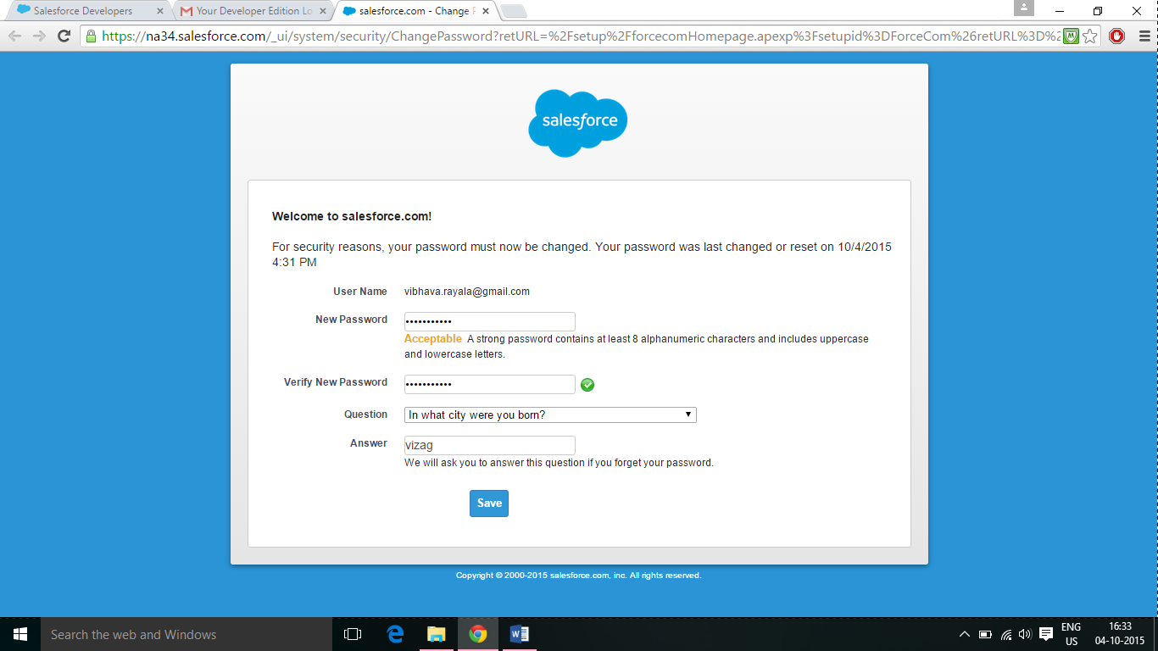

1. After creating the account on salesforce, this following page is displayed, you need to click on build app to create an app.

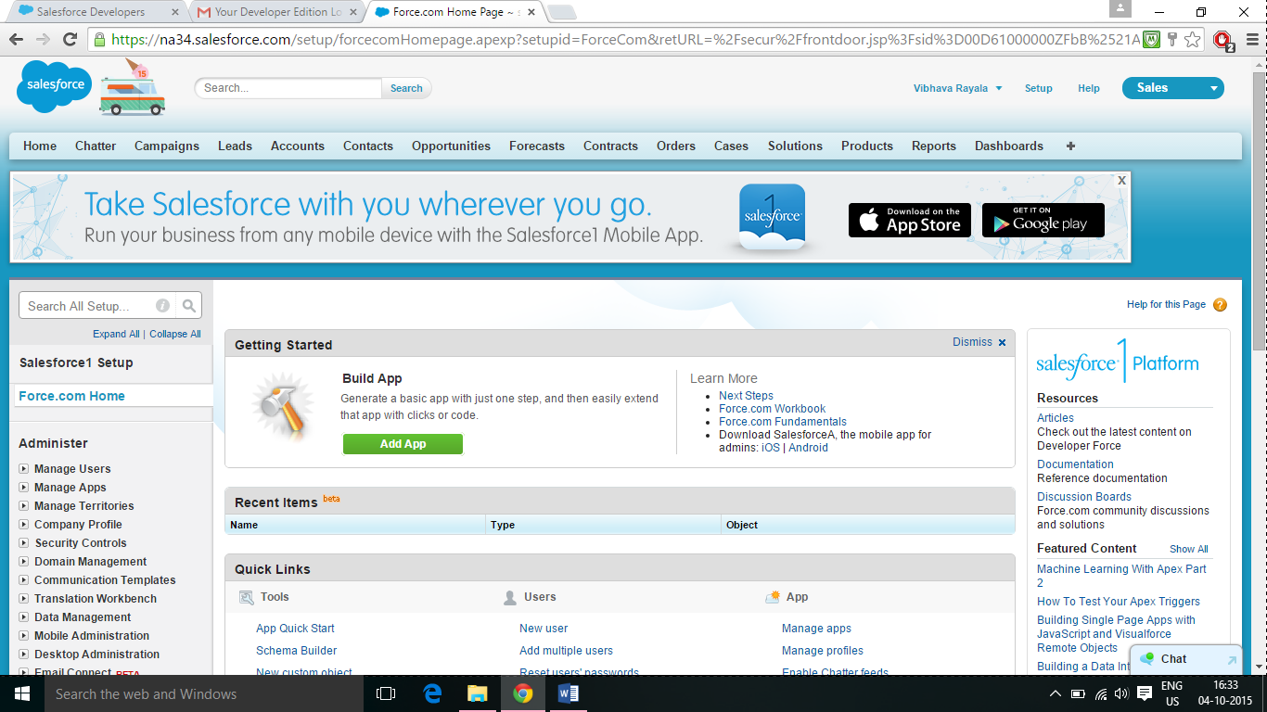

1. When you click on build app, a form appears on the screen to give the name of the app and label that you want to give to the app. I name my app Calendar and clicked on create.

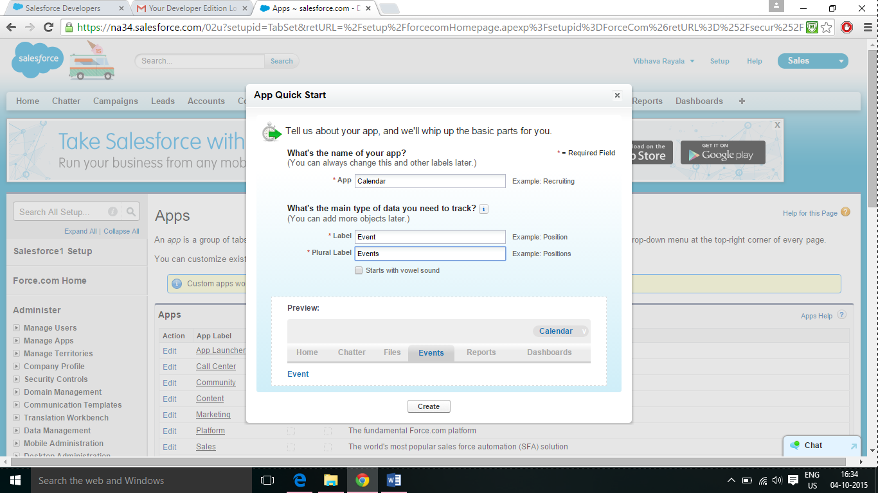

1. After you click on create, it creates an event, a permission set for calendar developer, and adds a chatter, files, reports and dashboards. I clicked on go to my app.

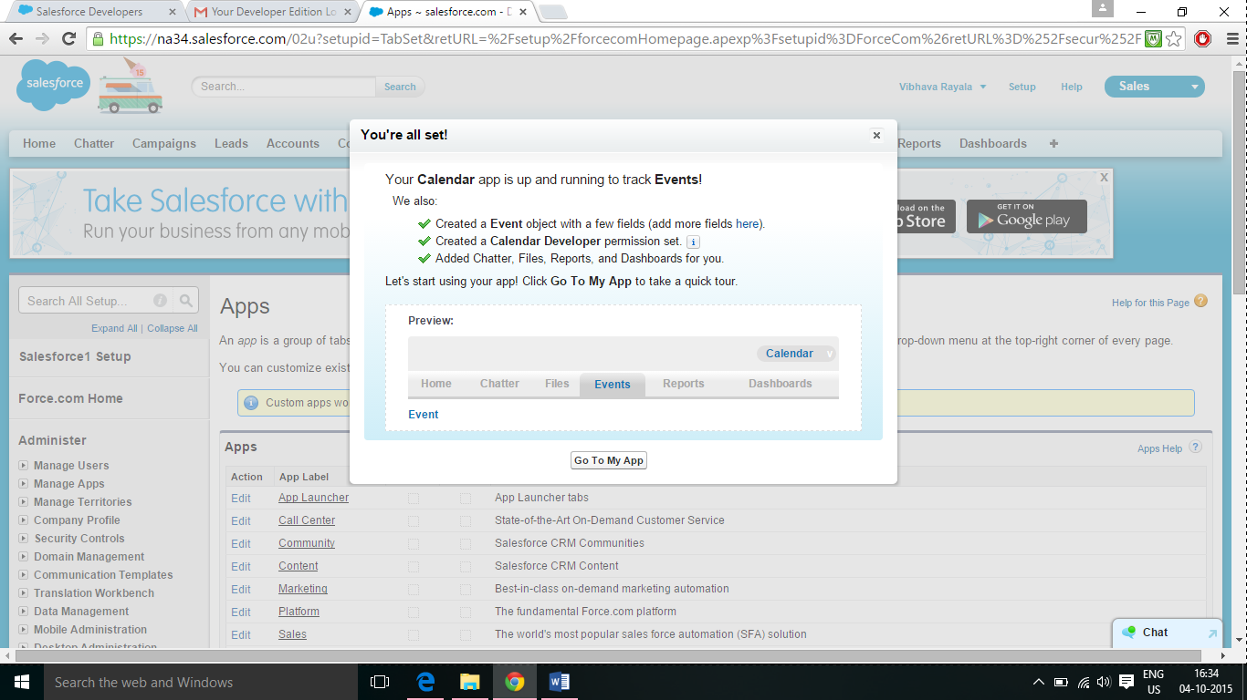

1. After you click on go to my app, the following home page of the calendar app displays.

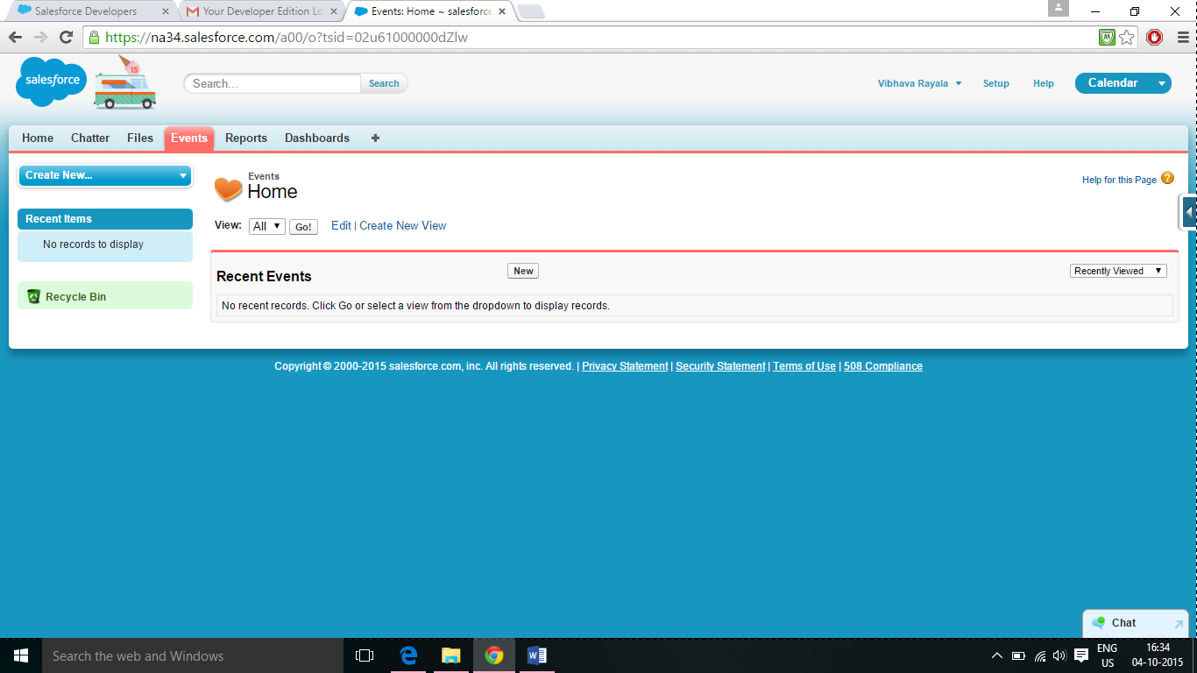

1. I clicked on create new button on the left side and created an event with the name Cloud Computing salesforce assignment.

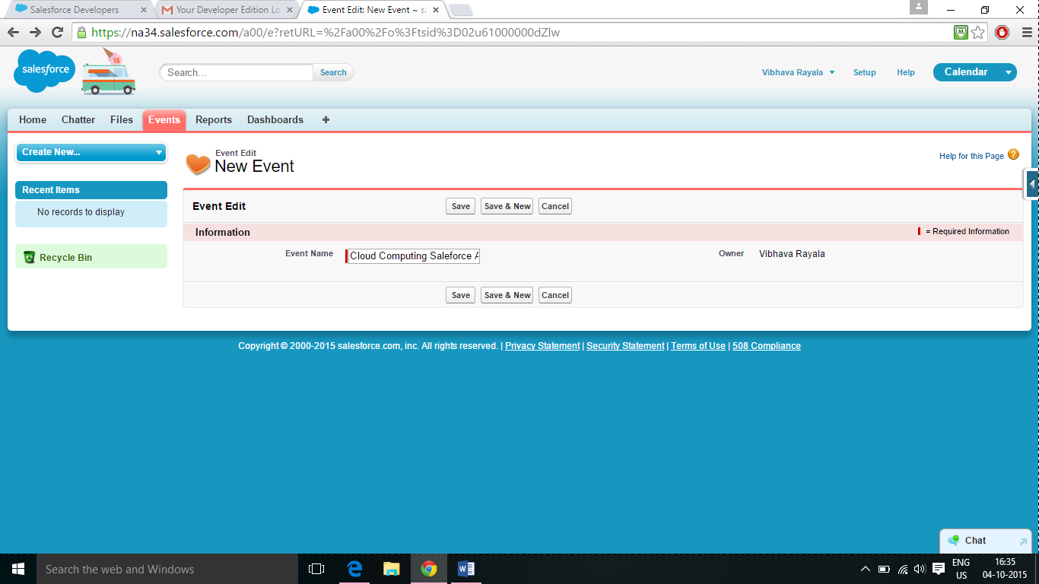

1. Once I create an event with the name cloud computing Salesforce assignment, it displays the same on the left side tool bar and I clicked on it, the following page displays.

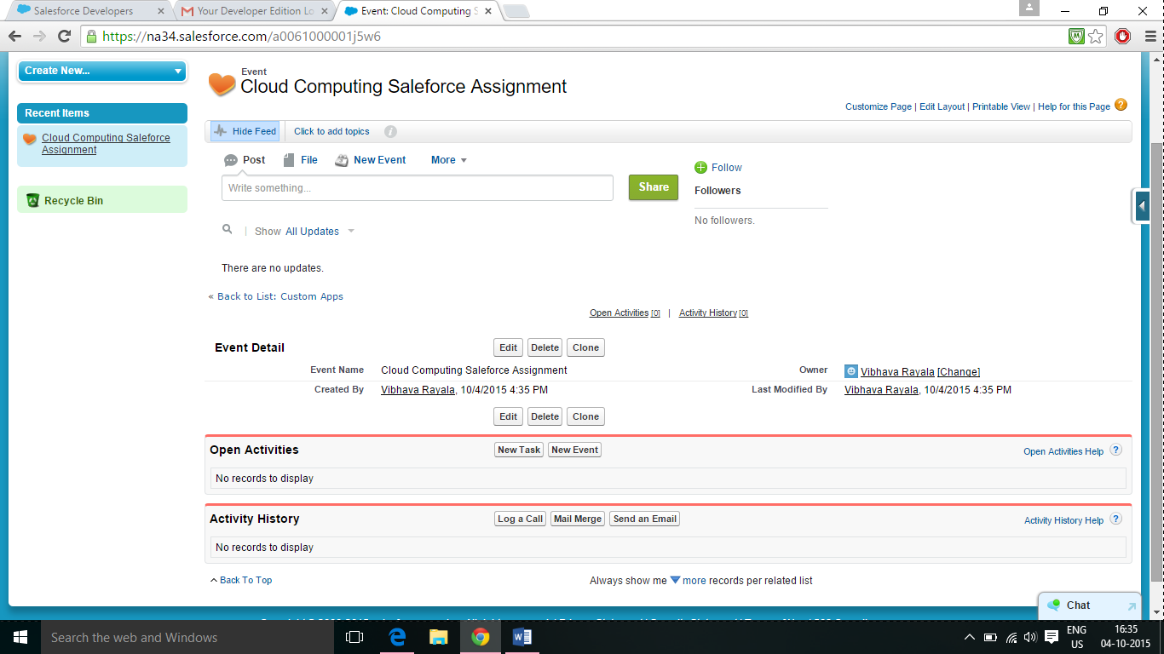

1. So you navigate to the toolbar on the left side and press the arrow mark and click on the view fields

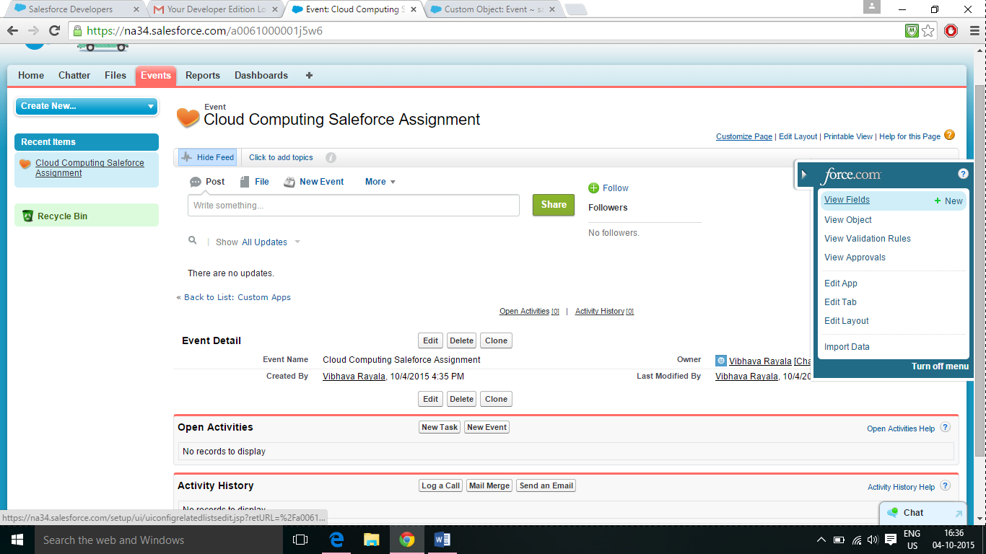

1. Once you click on view fields the following page gets displayed and under custom fields and relationships you click on new.

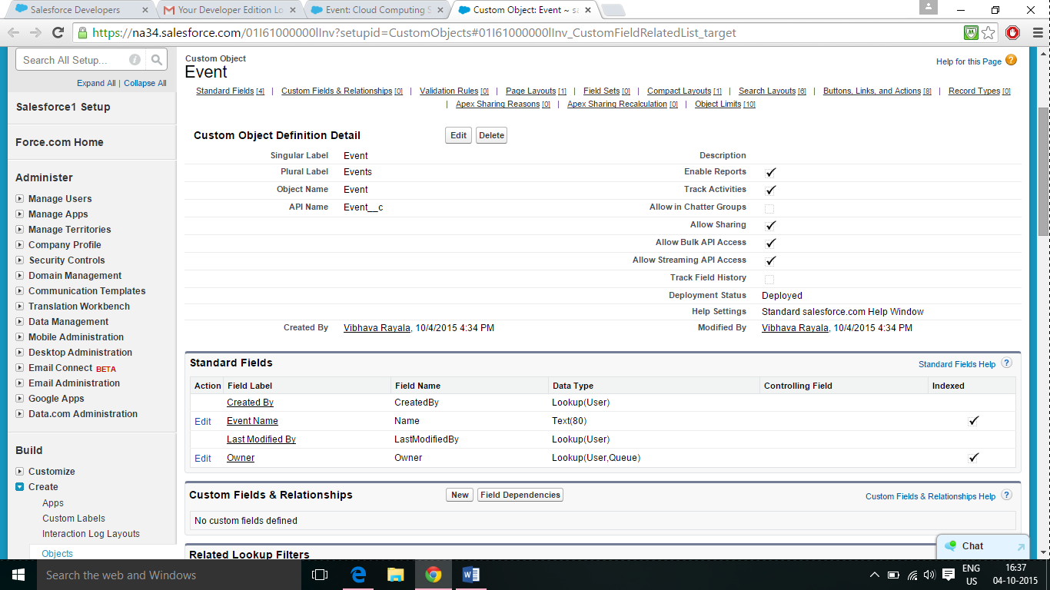

1. Once you click on new it asks you for a data type, and I’ve chosen date data type, once you’ve selected the data type that you want to work on, you click on next.

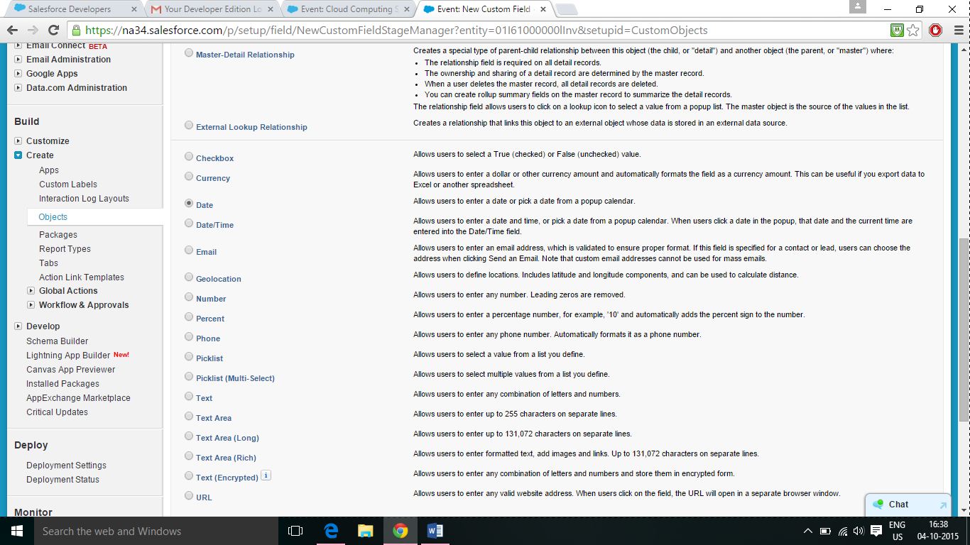

1. Next, it asks you for the field label , field name and the description, Ive given mine as date and description as event date is entered here and click on next.

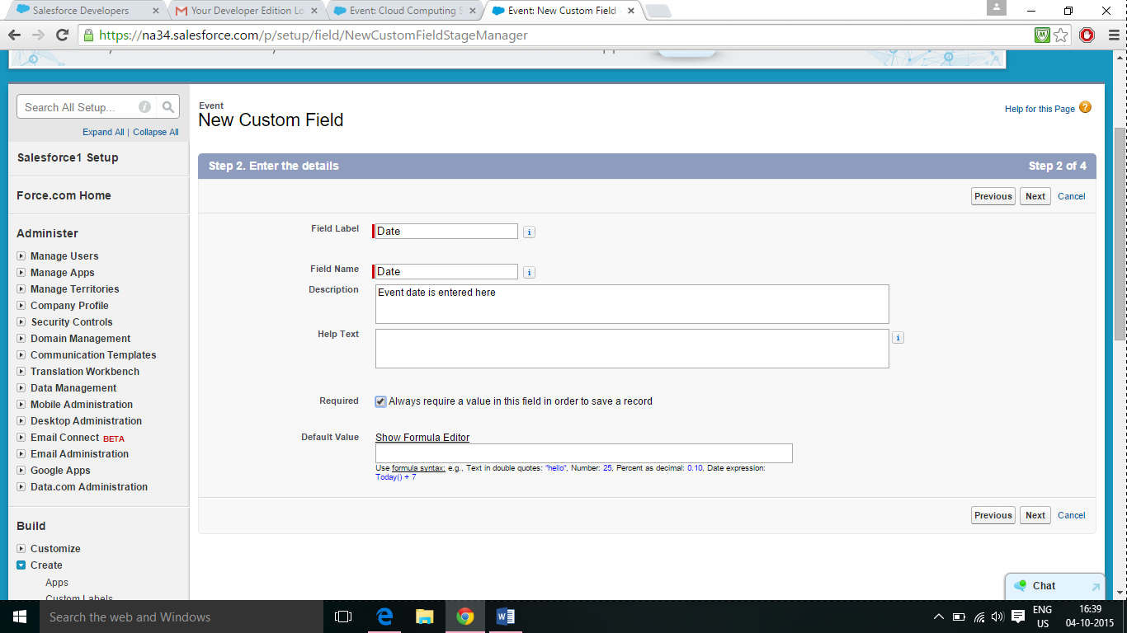

1. Once you click on next the following page gets displayed, with all the summary and permission sets and you click on next after this.

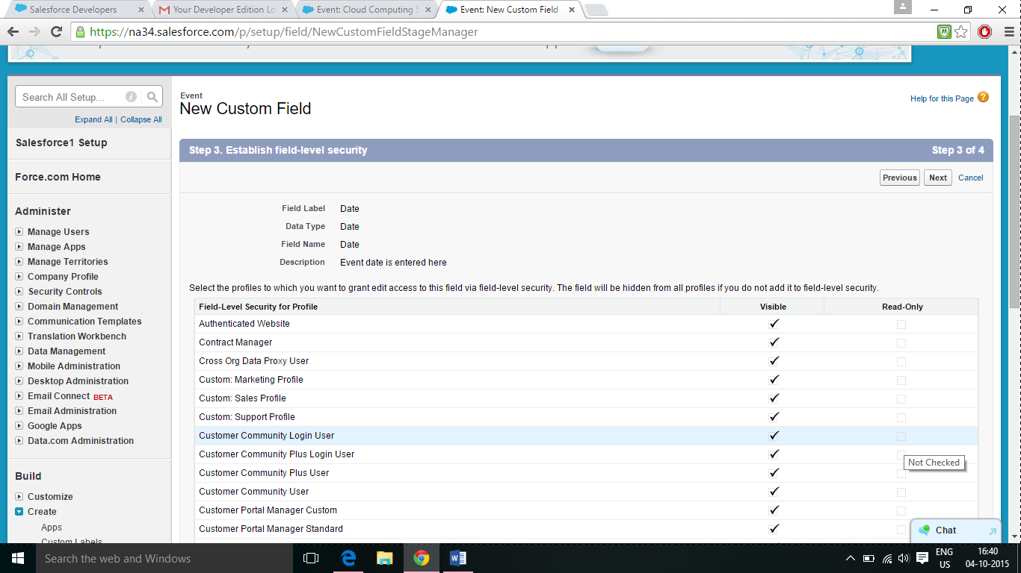

1. After you click on next, this page gets displayed, and you click on save on this page.

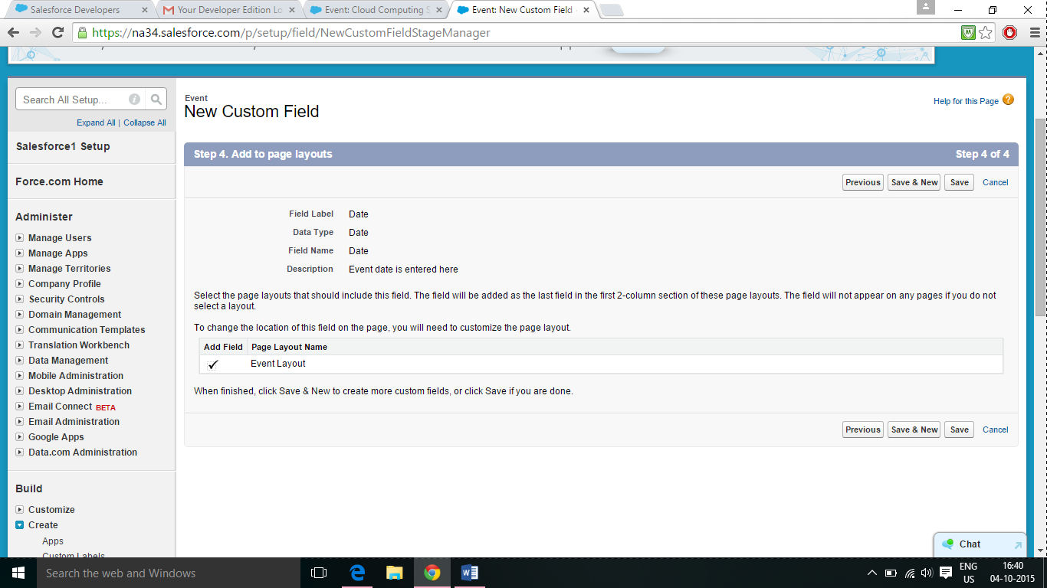

1. A field with date gets created, and it is displayed on the custom fields and relationships column below.

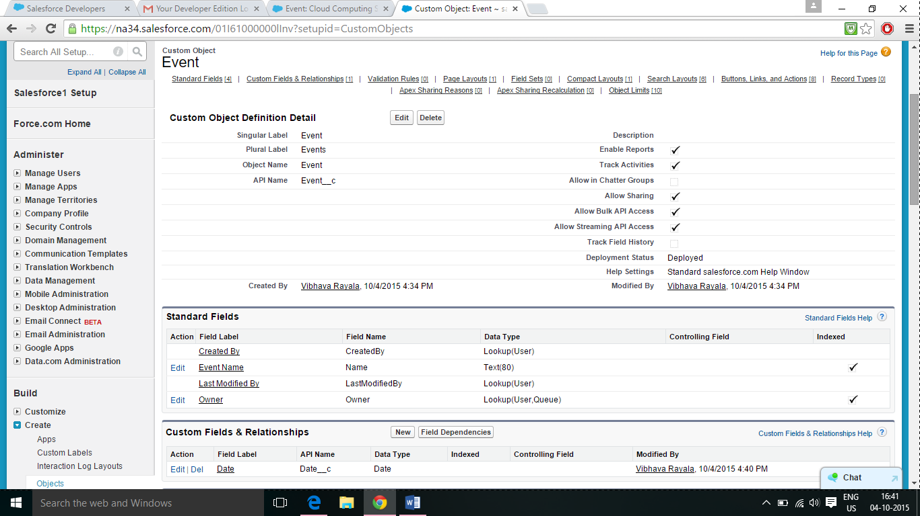

1. Now click on the event home page which is cloud computing salesforce assignment , and there is an option to enter the date now.

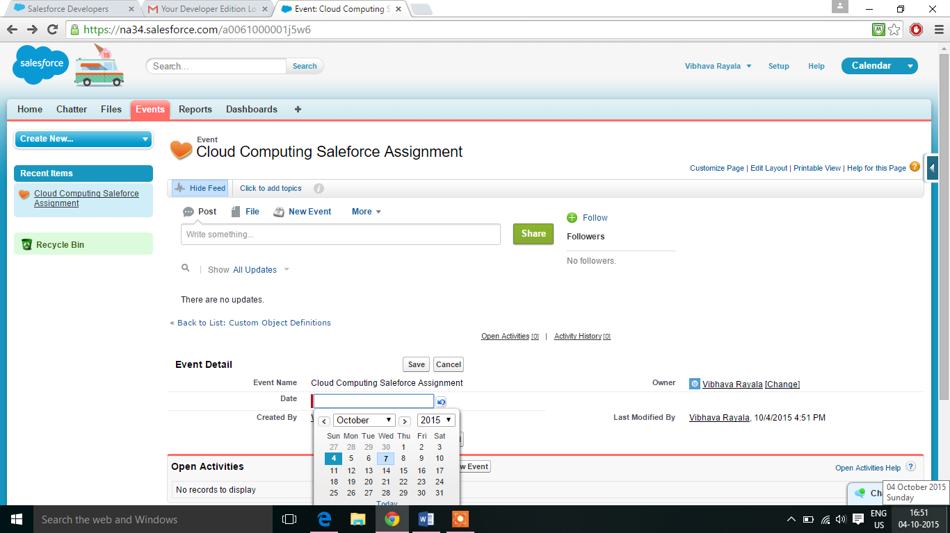

1. After I enter the date and click on save , it take my value for the date and gets saved like below.

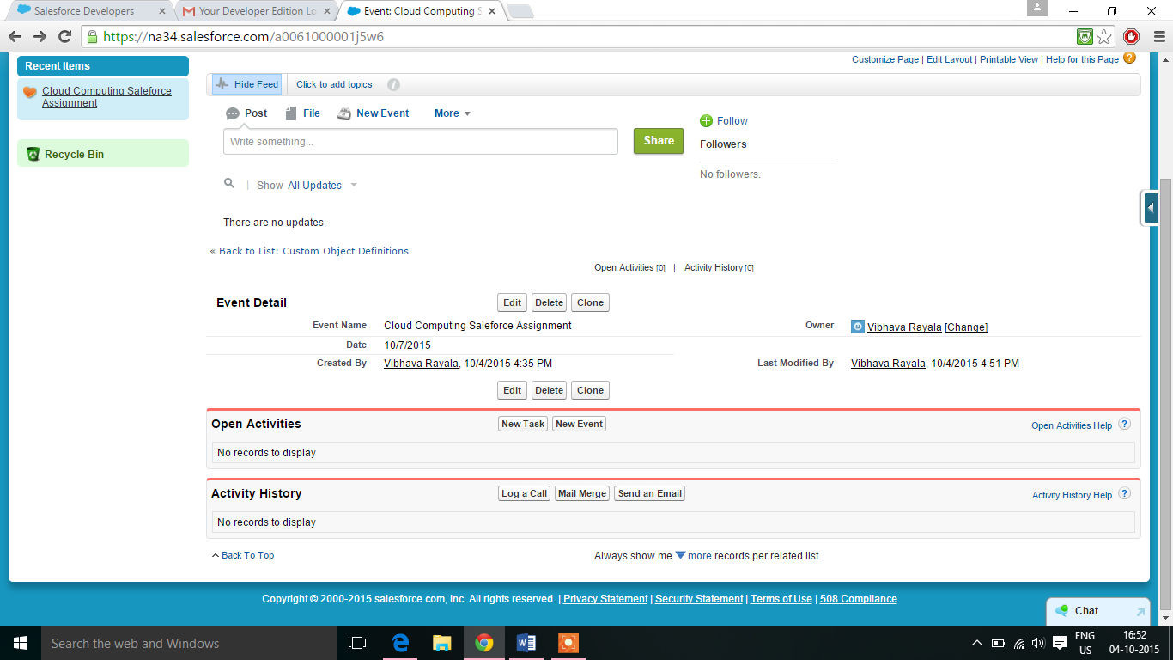

1. Similarly I’ve created 6 fields exactly like the procedure I’ve described above, and the field names are event name, date, professor, subject, email id, and contact.

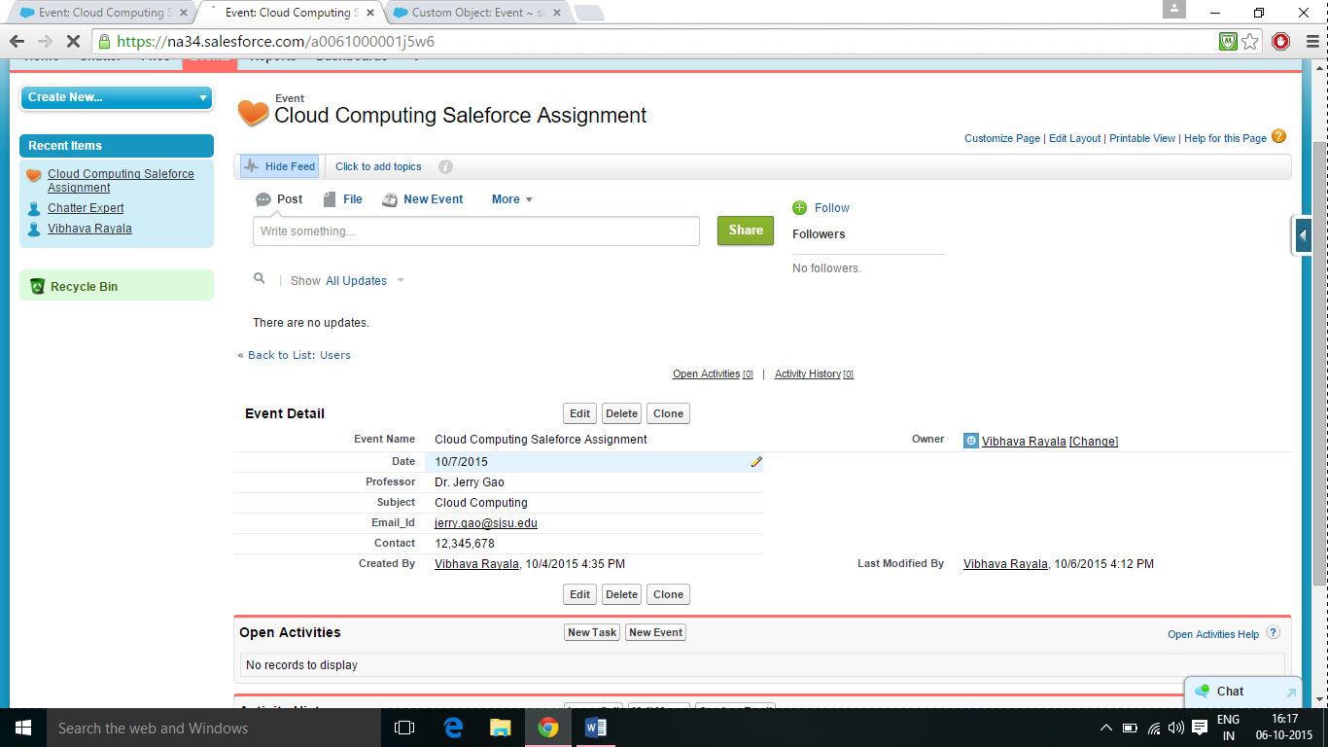

1. Now, I’ve to enable API, and on the homepage of my calendar App, I click on setup.

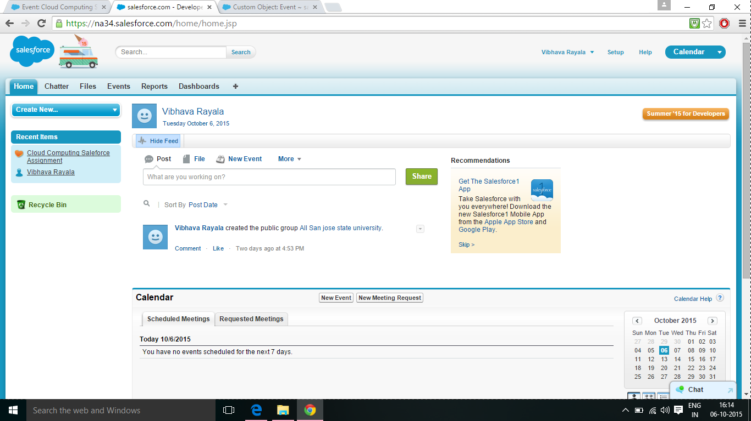

1. After I click on setup, I go to the left toolbar and click on permission sets.

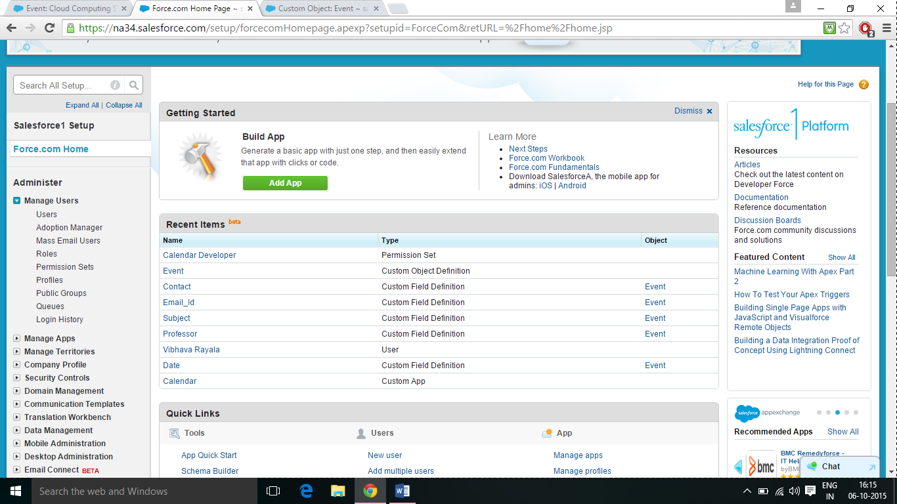

1. After I click on the permission sets, the app that I created which is the calendar app gets displayed, and I click on that app I created.

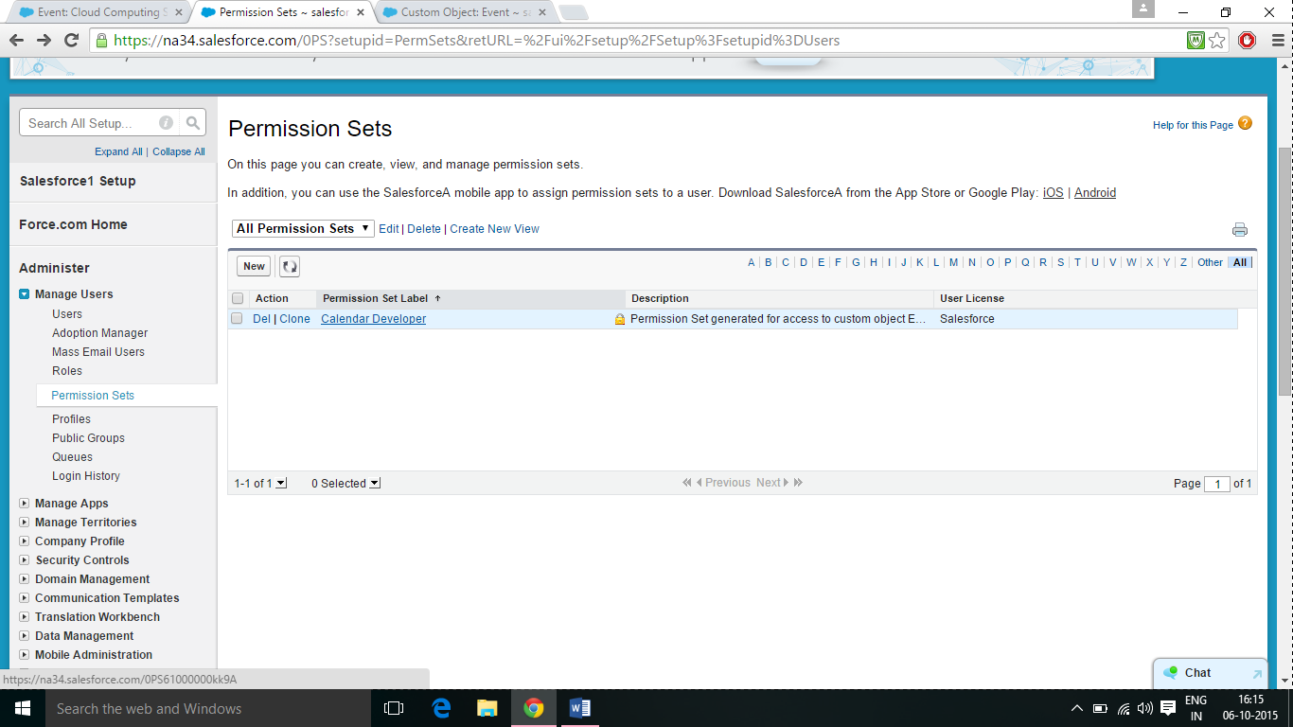

1. The following page gets displayed, and I click on app permssions.

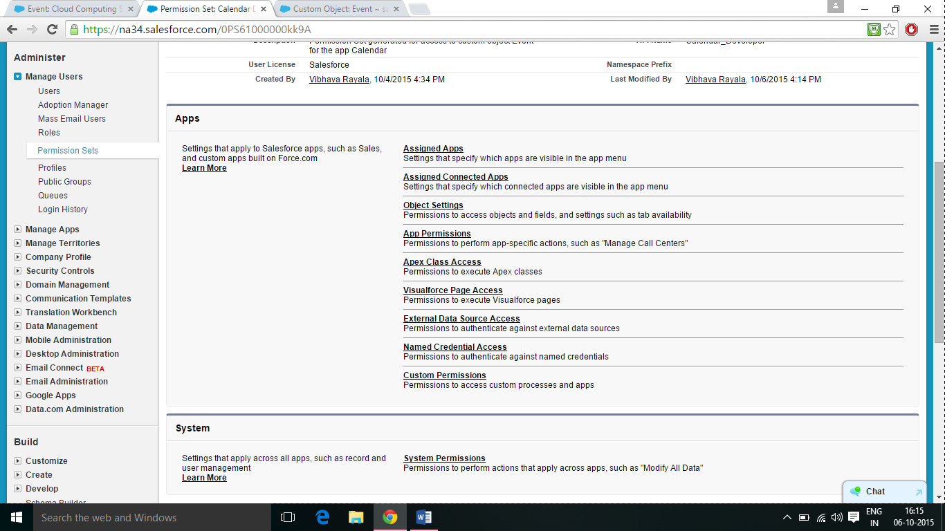

1. I go the app permissions and click on the drop down list and click on the system permissions

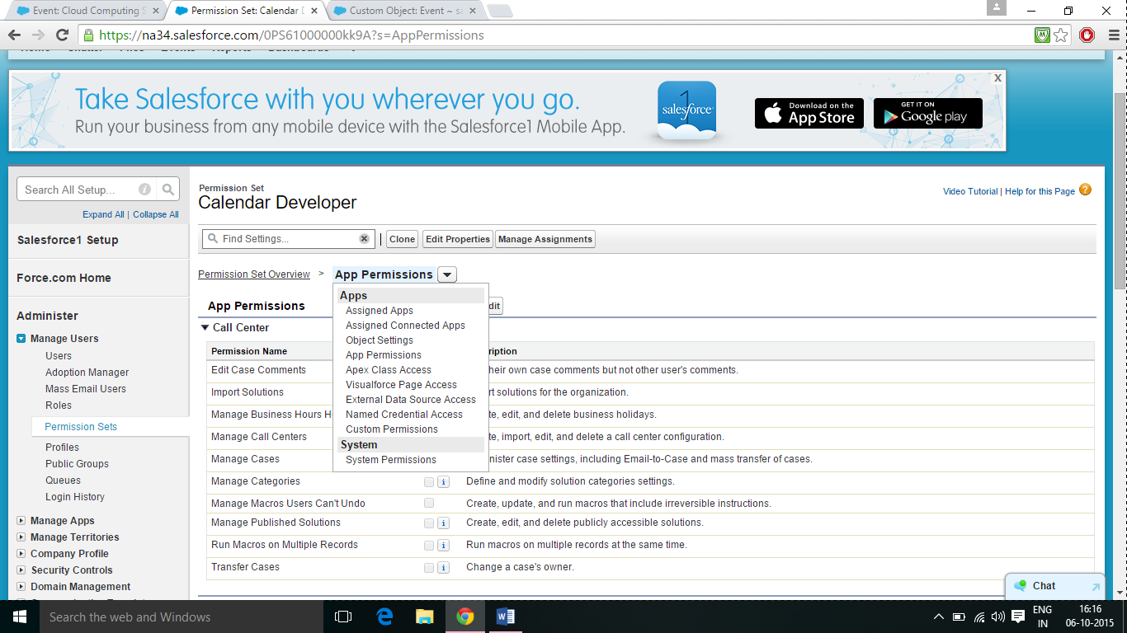

1. The following page gets displayed, with system permissions, and the you can see the checkbox on the right to API enabled is not checked.

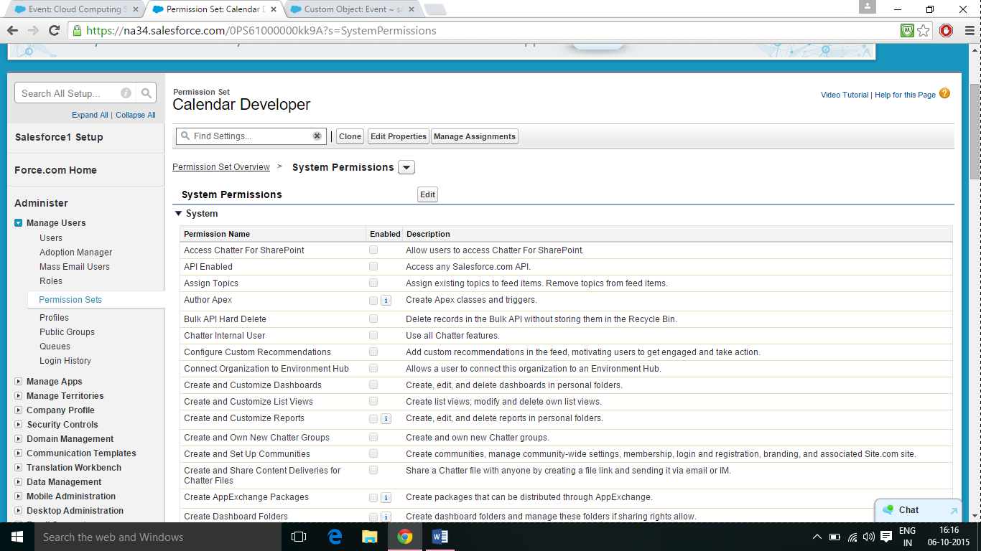

1. I checked the box near the API enabled, and now the API is enabled for the calendar App.

